F08 - Damaged Container Report: Instructions

- This form is to be used to record any damage noted to a container during loading or discharging operations.

2. The form should be completed immediately after the damage is sighted and a copy delivered to the stevedores and local agents as soon as possible thereafter. The signature of the Terminal or Stevedoring Company Representative should be obtained as agreement to the cause and extent of the damage. Irrespective of whether the Representative is prepared to sign the form, the form MUST be otherwise completed and submitted as required.

3. Reports are to be numbered consecutively from the start of every new Charter/Voyage period NN/YYYY.

4. Where a Charterer provides their own form for reporting container damage, this is to be used instead of this form. In this case, distribution will be as required by the charterer but always ensuring that a copy is submitted to the Company.

7. This form is completed by: The Chief Officer

9. Distribution: Original: SSFS File No. 12 - Cargo Information
Copy: To the Charterer
Copy: To the Terminal/Stevedores
Copy: To the local agent

Ship: | ______________________________ | Report Number: | _________________________
Port: | ______________________________ | Container Number: | _________________________
Date: | ______________________________ | Stowage Position: | _________________________
Time: | ______________________________ | Charterer: | _________________________

Container Size: | 20’ (TEU) / 40’ (FEU)
Container Type: | Standard / Open Top / High-Cube / Flatrack / Platform / Refrigerated / Tank
Details of Damage (Location marked on sketch below):
Cause of Damage (if known):
Name of Terminal Operator/Stevedoring Company:

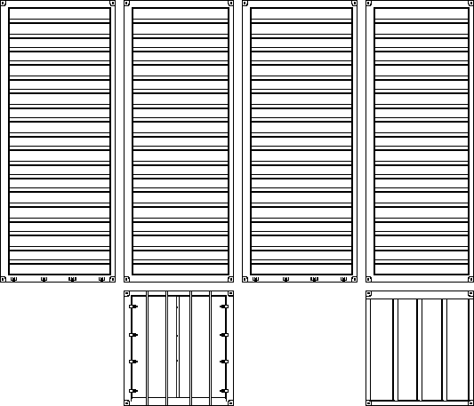
Bottom
Right
Top
Back
Left
Front

Cause and Extent of Damage Agreed:
______________________________  Master / Chief Officer Signature | ______________________________  Terminal / Stevedore Signature

